TYPES OF CAMP SET-UPS PROVIDED BY AFRISCREEN WHILE FILMING ON LOCATION IN SOUTHERN AFRICA

1. SEMI-PERMANENT BASE CAMP

This type of camp is only used on long term productions where the crew are going to be based primarily in one place, e.g. our Natural World films “A Wild Dog’s Story” and “Swamp Cats”. For “A Wild Dog’s Story” we had a camp set up in the Sankuyo concession for 2 years. For “Swamp Cats” we had a camp set up for a year in NG31 and then a year and a half in NG26

It is a tented camp that is set up for a period of 6 months or more. The camp is rustic and functional (still with long drop toilet) and is basically the same as a Full Base Camp (below), but as it will be standing for a period of time, it inevitably becomes more homely and you end up storing more equipment in it and having an additional storage tent. You have an outdoor shower, a solar power system is installed for hot water. The workshop and vehicle repair area is more comprehensively kitted for long term operations. The equipment tent is more comprehensive and doubles and an office and edit suite with logging, rough cuts and off-lines happening from the camp instead of from an office back in Maun. By the nature of being based out of the camp for a long period, the crew end up bringing more personal items and the camp soon fills “stuff”.

BBC Productions that have stayed in such a camp & producer references:
- A Wild Dog’s Story – Neil Nightingale, Mike Gunton, Jo Sarsby
- Ultimate Killers – camp share with our wild dog camp - Martin Hughes-Games, Steve Leonard, Vicky Webb, Freelancers: Simon Wagen, James Drake-Brockman
- Wild Africa –– Anuschka de Rohan
- Swamp Cats – Mike Gunton
- Planet Earth – Mark Linfield, Martyn Colbeck, Vanessa Berolwitz, Alastair Fothergill
- Nature’s Great Events – Peter Bassett

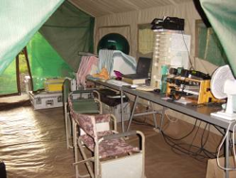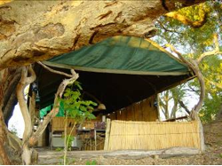
Equipment tent in Wild Dog Camp Gomoti film camp mess area

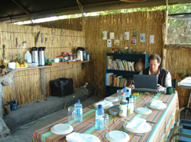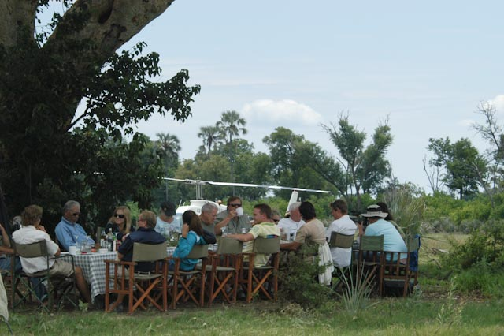
Main mess area – tent roof, open sides with Bush lunch set up in the wilds for
grass reed “walls” VIP clients like Morgan Freeman (above).
2. FULL BASE CAMP

For filming durations or over 4 weeks to 3 months (sometimes more). The length of filming and location determines the scale of kit required. A small base camp from which the crew satellite out filming daily and return to at night, or in the middle of the day if they are near enough. The crew also always carry fly-camping (lightweight overnight) camping equipment on the vehicles in case they are too far out from the base to return.

A detailed list of the camp contents will be provided, however a very brief overview looks like:

- Meru roof and equipment tent – where camera, sound and other equipment is stored.
- Mess tent - for eating out of the rain / sun and is used by the crew as camera maintenance area, laptop work are, etc. Tables, chairs
- Sleeping tents for each of the crew members, with relevant bedding
- Army tent roof for kitchen area so meals can be prepared out of the rain / sun. This is also where the food is stored out of reach of the hyenas and the 12V fridges, cooler boxes, etc. are kept. This is obviously kitted with all pots, pans, crockery, cutlery, flasks, glasses, cooking utensils, cooler boxes, Tupperware for food storage, washing up bowls and buckets,
- Cleaning items – rakes, brushes for cleaning tents and film vehicles, axes for chopping wood, etc.
- Heavyweight tarpaulin in rainy season strung between trees for keeping the camera vehicles dry (they are all open vehicles).
- This is also where we store the 40 gallon fuel drums, additional drinking water if need be and comprehensive tools and spares kits.
- Generator and inverter (converting 12V to 220 to charge camera batteries and run laptops for editing, etc)
- Communications: Base sat phone, Base VHF radio that talks to the camera vehicles and back to Maun production office.
- Navigation equipment
- Ablutions – long drop toilet and bucket showers or porta-shower that runs off the vehicle batteries.
- Paraffin lanterns and 12V working lights.
- Comprehensive first aid kit.

Note: This list does not include the items that are carried on the film vehicle full time.

Minimum crew requirement over and above the shooting crew:
2 people – who wear many hats: safely officers, rescue of stuck / broken camera vehicle, camp hands (to keep camp tidy and to prevent it from being trashed by the wildlife), cook, mechanic, supply runs.
They obviously need to have a vehicle.

BBC Productions that have stayed in such a camp & producer references:
- Planet Earth – Wild Dog heligimbal filming (Base camp that accommodated a large crew for 2 weeks – heligimbal, making of, ground camera teams x 2 and stills)
- Contact: Mark Linfield, Vanessa Berlowitz, Martyn Colbeck
- Freelancers: Michael Kelem, Ben Osborne, Matt Norman, Other: Peter Perlstein (Helicopter pilot)
- Planet Earth - We also set up a Full base camp for Planet Earth in Savute for filming the lions / elephants predation sequences at night, even though the shoot duration was 3 weeks each year.
  - Contact: Jonny Keeling, freelancers: Justine Evans, Nick Turner, Ben Osborne

- Incredible Journeys - Full base camp with mobile capabilities (i.e. a truck that could move the whole base camp when needed – which we did across the Okavango).
- Contact: Martin Hughes-Games, Steve Leonard, Giles Badger, Simon Wagen, Jake Drake-Brockman

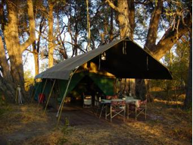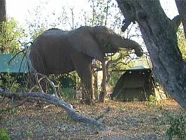
Main mess area Sleeping tents

3. FLY CAMP

Used for filming of up to 4 weeks duration. Length of filming and location determines the scale of kit required.
This type of camp is also used when the crew are moving around a lot and only in any given location for a few days. They could be on the move for several months and in such a case the Production office becomes the Base that they return to periodically for essential vehicle repairs and maintenance.

A detailed list of the camp contents will be provided, however a very brief overview looks like:

- Small 3 x 3 m equipment tent – where camera, sound and other equipment is stored.
- Mess area tarpaulin that is stung between trees - for eating out of the rain / sun and is used by the crew as camera maintenance area, laptop work are, etc. Tables, chairs
- Sleeping tents for each of the crew members, with relevant bedding
- Tarpaulin (note: not tent) for kitchen area so meals can be prepared out of the rain / sun. This is also where the food is stored out of reach of the hyenas and the 12V fridges, cooler boxes, etc. are kept. This is obviously kitted with all pots, pans, crockery, cutlery, flasks, washing up bowls and buckets, brushes for cleaning tents and film vehicles, axes for chopping wood, etc.
- Heavyweight tarpaulins in rainy season strung between trees for keeping the camera vehicles dry (they are all open vehicles).
- 40 gallon fuel drums, additional drinking water and comprehensive tools and spares kits.
- Generator and inverter (converting 12V to 220 to charge camera batteries and run laptops for editing, etc)
- Communications: Base sat phone, Base VHF radio that talks to the camera vehicles and back to Maun production office.
- Navigation equipment
- Ablutions – long drop toilet and or porta-shower that runs off the vehicle batteries.
- Paraffin lanterns and 12V working lights.
- Comprehensive first aid kit.

Note: This list does not include the items that are carried on the film vehicle full time.

Minimum crew requirement over and above the shooting crew:
2 people – who wear many hats: safely officers, rescue of stuck / broken camera vehicle, camp hands (to keep camp tidy and to prevent it from being trashed by the wildlife), cook, mechanic, supply runs.
They obviously need to have a vehicle.
BBC Productions that have stayed in such a camp & producer references:
- Wild Africa – Shakawe – skimmers & Fish eagles (Philip Lovel & Anuschka de Rohan)
- Planet Earth – Wild Dog filming in Xakanaxa
  - Contact freelancer: Martyn Colbeck
- Planet Earth – Quelea filming in the pans
- Planet Earth – Flamingo’s – Makgadikgadi
- Planet Earth – Flood arrival – upper delta - NG26 (Abu) – Mike and Graham Springer
- Planet Earth – Flood arrival & buffalo – NG29
  - Contact freelancer: Mark Linfield, Martyn Colbeck
- Earth’s Great Events – Savute
- Life – Flamingo’s

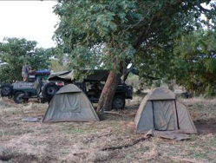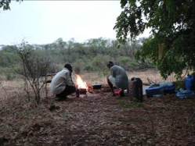
Sleeping tents & vehicles “Kitchen”

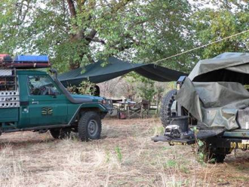
Make-shift mess area with tarpaulin

